# VISVESVARAYA TECHNOLOGICAL UNIVERSITY

**“JNANA SANGAMA”, BELAGAVI -590018.**

**An Internship Report on**

**“Data Analytics Internship”**

**SUBMITTED IN PARTIAL FULFILMENT FOR THE AWARD OF THE DEGREE OF**

**Bachelor of Engineering In**

**COMPUTER SCIENCE AND ENGINEERING**

**Submitted By**

**YUKTHI R (1JB21CS184)**

**Internship carried out at:**

**BOSCH**

**Under the guidance of**

**INTERNAL GUIDE**

**Dr. Bindiya M K Professor**

**Dept. of CSE, SJBIT**

**EXTERNAL GUIDE**

**Kumaresan S Manager**

**Bosch**



**DEPARTMENT OF COMPUTER SCIENCE AND ENGINEERING**

**SJB INSTITUTE OF TECHNOLOGY**

**An Autonomous Institute under VTU**

**#67, BGS HEALTH AND EDUCATION CITY, Dr Vishnuvardhan Road, Kengeri, Bengaluru-560060.**

**2024 - 2025**

### || Jai Sri Gurudev ||

**Sri Adichunchanagiri Shikshana Trust ®**

SJB INSTITUTE OF TECHNOLOGY

**An Autonomous Institute under VTU**

**No.67, BGS Health & Education City, Dr.Vishnuvardhan Rd, Kengeri, Bengaluru, Karnataka 560060**

# Department of Computer Science and Engineering



**CERTIFICATE**

This is to certify that the Internship report entitled “**INDUSTRY INTERNSHIP**” (21INT82) carried out by **YUKTHI R** bearing USN **1JB21CS184** is bonafide student of **SJB Institute of Technology** in partial fulfilment for 8th semester of **BACHELOR OF ENGINEERING** in **COMPUTER SCIENCE AND ENGINEERING** of the **Visvesvaraya Technological University**, **Belagavi** during the academic year **2024-25.** It is certified that all corrections/suggestions indicated for Internal Assessment have been incorporated in the Report deposited in the Departmental library. The Internship report has been approved as it satisfies the academic requirements in respect of Internship work prescribed for the said Degree.

|  |  |  |  |
| --- | --- | --- | --- |
| **Signature of Guide**  **Dr. Bindiya M K** |  | **Signature of HOD**  **Dr. Krishna A N** | **Signature of Principal**  **Dr. K. V. Mahendra Prashanth** |
| **Professor** |  | **Professor & Head** | **Principal, SJBIT** |
| **Dept. of CSE, SJBIT** |  | **Dept. of CSE, SJBIT** |  |

**EXTERNAL EXAMINERS SIGNATURE WITH DATE**

**INTERNSHIP COMPLETION CERTIFICATE**

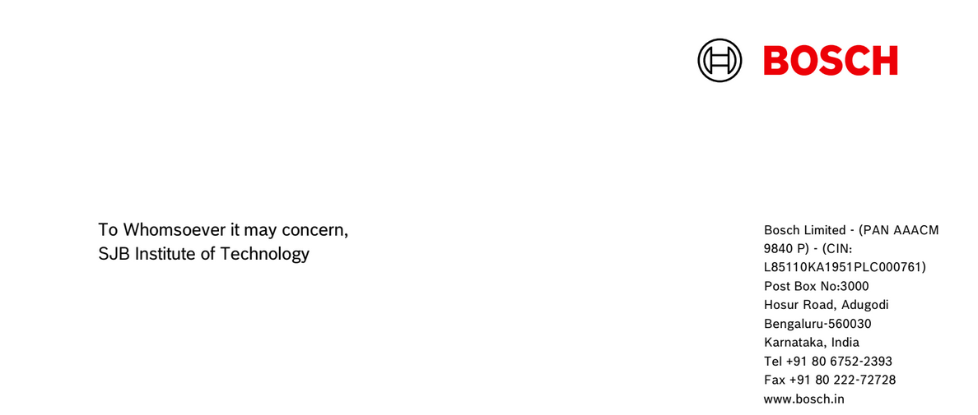

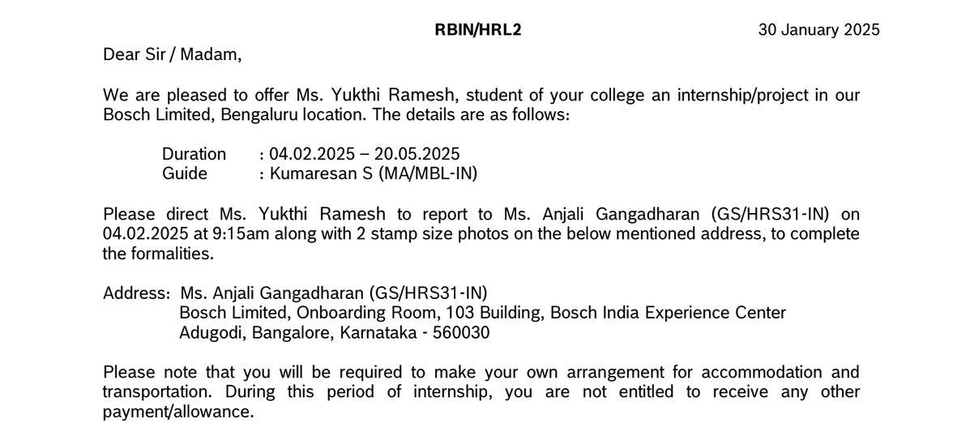

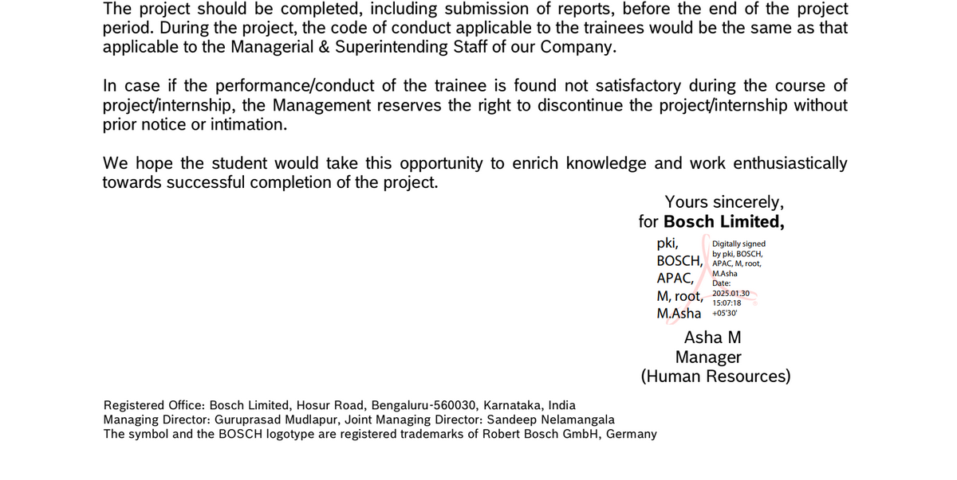

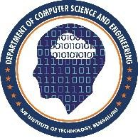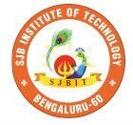

**ACKNOWLEDGEMENT**

I would like to express my profound grateful to His Divine Soul **Jagadguru Padmabhushan Sri Sri Sri Dr. Balagangadharanatha Mahaswamiji** and His Holiness **Jagadguru Sri Sri Sri Dr. Nirmalanandanatha Mahaswamiji** for providing us an opportunity to complete my academics in this esteemed institution.

I would also like to express my profound thanks to **Revered Sri Sri Dr. Prakashnath Swamiji**, Managing Director, BGS & SJB Group of Institutions, for his continuous support in providing amenities to carry out this Industry Internship in this admired institution.

I express my gratitude to **Dr. Puttaraju,** Academic Director, BGS & SJB Group of Institutions, for providing me with an excellent facility and academic ambience, which have helped me in satisfactory completion of the Industry Internship.

I express my gratitude to **Dr. K. V. Mahendra Prashanth**, Principal, SJB Institute of Technology, for providing me an excellent facilities and academic ambience, which have helped me with the satisfactory completion of an Industry Internship.

I extend my heartfelt gratitude to all the Deans of SJB Institute of Technology for their unwavering support, cutting-edge facilities, and the inspiring academic environment, all of which played a pivotal role in the successful completion of my Industry Internship.

I extend my sincere thanks to **Dr. Krishna A N,** Head of the Department, Computer Science and Engineering, for providing me an invaluable support throughout the period of my Industry Internship.

I wish to express my heartfelt gratitude to my guide **Dr. Bindiya M K,** Professor, Department of CSE for her valuable guidance, suggestions and cheerful encouragement during the period of my Industry Internship.

I express my truthful thanks to Internship Coordinator **Dr. Prasad A Y**, Associate Professor, Department of CSE, for his valuable support throughout my Industry Internship period.

Finally, I take this opportunity to extend my earnest gratitude and respect to my parents, Teaching & Non- teaching staffs of the department, the library staff and all my friends, who have directly or indirectly supported me during the period of my Industry Internship.

Regards,

iii **Yukthi R [1JB21CS184]**

**DECLARATION BY THE STUDENT**

I, **YUKTHI R [1JB21CS184]** student of 8th semester Computer Science and Engineering, **SJB INSTITUTE OF TECHNOLOGY,** hereby declare that the Internship entitled **“DATA ANALTICS INTERSNHIP”** submitted to the **Visvesvaraya Technological University, Belagavi** during the academic year 2024-2025, is a record of an original work done by me under the guidance of my internal guide **Dr. Bindiya M.K,** Professor,Department of Computer Science and Engineering, SJB Institute of Technology, Bangalore and External supervisor **Mr.** **Kumaresan S, Manager**, Bosch Ltd. This Internship report is submitted in partial fulfilment for the award of Computer Science and Engineering. The results embodied in this report have not been submitted to any other University or Institute for the award of any degree.

Date :  **YUKTHI R**

[1JB21CS184]

Place : Bangalore

**EXECUTIVE SUMMARY**

This report documents the internship work completed by **Yukthi R [1JB21CS184]** as part of the course *Industry Internship (21INT82)* during the academic year 2024–2025. The internship was undertaken at **Bosch**, a global leader in technology and services, particularly in the Mobility Aftermarket sector, the internship focused on leveraging data analytics to support intelligent decision-making within automotive service operations. Bosch's data-driven approach to enhancing customer experience and operational efficiency offered a unique opportunity to work at the intersection of analytics, automation, and applied machine learning.

The internship spanned a duration of **15 weeks**, from **February 2025 to May 2025**, and was carried out under the academic supervision of **Dr. Bindiya M K**, **Professor**, Department of Computer Science and Engineering, **SJB Institute of Technology**.

The core project centered around developing a robust **data-mapping system** that could intelligently associate incomplete vehicle registration information with a unique internal identifier. This system is intended to support Bosch service centers in accurately identifying vehicle models and their compatible spare parts, even when only partial data is available. The role involved extracting meaningful patterns from raw vehicle datasets by analyzing attributes such as brand, model, fuel type, and engine specifications.

The technical stack primarily included **Python (Pandas)** for **data cleaning** and **transformation**, and the **Random Forest algorithm** to build a **predictive model** capable of mapping input features to the corresponding unique identifier. **Data visualization** was carried out using **Tableau**, enabling stakeholders to gain insights across brands, models, and prediction accuracy. Additionally, **Microsoft** **Excel** was used for supplementary analysis and **data validation**.

Beyond technical contributions, the internship fostered a deeper understanding of enterprise data workflows and **analytics-driven business impact**. It reinforced best practices in data science, including documentation, stakeholder communication, and continuous improvement. The experience also encouraged **collaborative teamwork** and introduced soft skills essential for large-scale project development within corporate environments.

**TABLE OF CONTENTS**

|  |  |  |
| --- | --- | --- |
| **CHAPTER** | **DESCRIPTION** | **PAGE NO.** |
| Certificate |  | i |
| Industry Certificate |  | ii |
| Acknowledgement |  | iii |
| Declaration |  | iv |
| Executive Summary |  | v |
| Table of Contents |  | vi |
| List of Figures |  | viii |
| Chapter 1 | About the Company | 1 |
| 1.1 | Bosch - Overview | 1 |
| 1.2 | Bosch’s Role in the Future of Mobility | 2 |
| 1.3 | Work Culture and Innovation at Bosch | 3 |
| Chapter 2 | About the Department | 4 |
| 2.1 | Introduction to the Mobility Aftermarket Division | 4 |
| 2.2 | Team Composition and Tools Used | 5 |
| 2.3 | Focus Areas | 8 |
| Chapter 3 | Tasks Performed | 10 |
| 3.1 | Orientation and Initial Knowledge Transfer | 10 |
| 3.2 | Segment Classification and Preliminary Projects | 11 |
| 3.3 | Raw Data Analysis and Preprocessing | 12 |
| 3.4 | Mapping Vehicle Profiles to Unique Keys | 14 |
| 3.5 | Collaboration, Agile Practices, and Documentation | 16 |
| 3.6 | Testing, Debugging, and Iterative Refinement | 19 |
| 3.7 | Learning and Documentation | 20 |
| Chapter 4 | Reflection Notes | 22 |
| 4.1 | Technical Skills Acquired | 22 |

|  |  |  |
| --- | --- | --- |
| 4.2 | Problem-Solving and Debugging Skills | 23 |
| 4.3 | Exposure to AI and Language Models | 24 |
| 4.4 | Professional and Communication Development | 26 |
| 4.5 | Real-World Project Exposure | 27 |
| Conclusion |  | 29 |
| References |  | 30 |

# LIST OF FIGURES

|  |  |  |
| --- | --- | --- |
| **FIGURE NO.** | **DESCRIPTION** | **PAGE NO.** |
| 1.1 | Bosch Logo | 1 |
| 3.1 | Vehicle data | 13 |
| 3.2 | Random Forest Algorithm | 15 |
| 3.3 | Tableau visualization | 16 |
| 3.4 | Flowchart | 18 |

**CHAPTER 1**

# ABOUT THE COMPANY

## Bosch – Overview

Founded in 1886 by Robert Bosch, the Bosch Group is a leading global supplier of technology and services. With its headquarters in Stuttgart, Germany, Bosch operates in more than 60 countries and employs over 400,000 associates worldwide. The company is known for its innovation-driven approach across four major sectors: Mobility Solutions, Industrial Technology, Consumer Goods, and Energy and Building Technology.

 **Fig 1.1 Bosch Logo**

Bosch places a strong emphasis on research and development (R&D), investing nearly 10% of its annual revenue in innovation. This commitment has made Bosch a pioneer in cutting-edge technologies such as artificial intelligence (AI), electrification, IoT (Internet of Things), and automated driving. The company's mission—“Invented for Life”—reflects its vision to enhance quality of life through innovative and sustainable solutions.

In the field of Mobility Solutions, Bosch is a global market leader. It offers advanced components and systems for vehicle safety, powertrain, connectivity, and driver assistance. Bosch continues to transform the future of mobility through its efforts in electrification, automation, and digitalization of transportation systems.

Bosch also upholds strong corporate values such as sustainability, social responsibility, and employee development. Its long-standing reputation is built on technical excellence, ethical business practices, and global cooperation.

Bosch also maintains a robust global innovation ecosystem, collaborating with universities, research institutes, startups, and public institutions. It holds thousands of active patents and operates numerous innovation centers worldwide. The company’s strategy is aligned with long-term global trends like urbanization, climate change, and digitization, allowing it to remain at the forefront of technological transformation across industries.

## Bosch’s Role in the Future of Mobility

Bosch is at the forefront of transforming the automotive industry through its commitment to smart, sustainable, and connected mobility. With increasing urbanization and global efforts to reduce carbon emissions, the traditional concept of mobility is rapidly evolving. Bosch responds to this transformation by investing in next-generation technologies such as electric vehicles (EVs), hydrogen fuel cells, and automated driving systems, aiming to make mobility safer, cleaner, and more convenient.

One of Bosch’s key areas of innovation is in electrification. The company produces complete electric drive systems, inverters, and battery management solutions for electric vehicles, helping OEMs accelerate the transition to carbon-neutral transportation. In parallel, Bosch is developing charging infrastructure solutions and energy-efficient power electronics, enabling widespread EV adoption.

Automation is another major focus area. Bosch is developing Advanced Driver Assistance Systems (ADAS) that contribute to increased road safety and prepare vehicles for higher levels of autonomy. These systems include lane-keeping assistance, automatic emergency braking, adaptive cruise control, and parking assistance. All of these are backed by deep AI research and real-time data processing capabilities that Bosch continues to refine.

Connectivity is also a pillar of Bosch’s future mobility vision. Through Vehicle-to-Everything (V2X) communication, Bosch is enabling vehicles to interact with infrastructure, pedestrians, and other vehicles in real-time. This helps reduce accidents, manage traffic congestion, and provide timely maintenance alerts, improving the driving experience. Bosch also works on fleet management platforms and telematics systems, optimizing logistics and commercial vehicle operations.

In addition to individual technologies, Bosch’s holistic approach to mobility involves integrating all these innovations into a unified ecosystem. The company envisions a world where cars are autonomous, intelligent, and part of smart city infrastructure. Its mobility platform integrates AI, IoT, cloud computing, and big data analytics, proving Bosch's role not just as an automotive supplier but as a strategic mobility solutions provider shaping the future of transportation.

## Work Culture and Innovation at Bosch

Bosch’s work culture is built on a foundation of integrity, transparency, and collaboration. The company emphasizes mutual respect, diversity, and a people-first approach. Employees are encouraged to take ownership of their work and contribute meaningfully, which fosters a sense of purpose and accountability. Bosch promotes open communication, regular feedback, and active employee engagement at all levels.

One of the core aspects of Bosch’s culture is its strong focus on continuous learning and development. The company offers access to a wide array of internal and external training programs, covering both technical and soft skills. Employees are encouraged to explore upskilling opportunities in areas like AI, data analytics, project management, and sustainability. Internship programs, such as the one I participated in, are structured to deliver meaningful exposure and mentorship.

Bosch also fosters a culture of innovation, where experimentation is encouraged, and failure is considered a stepping stone to progress. Teams are given the freedom to ideate, prototype, and iterate on solutions. The presence of innovation hubs and cross-functional teams helps break silos and encourages knowledge sharing across departments. Tools like design thinking and agile methodologies are regularly used in project workflows.

Another defining feature of Bosch's workplace is its commitment to work-life balance and employee well-being. Flexible working hours, hybrid working models, health programs, and wellness initiatives contribute to a supportive and productive environment. The company values mental health and ensures that employees have access to necessary support systems and recreational opportunities, such as team outings and offsites.

Lastly, Bosch believes in building sustainable relationships with not only customers but also employees and the larger community. The company actively engages in CSR initiatives, environmental conservation, and community outreach programs. Employees are encouraged to participate in these activities, reinforcing a sense of corporate responsibility and purpose beyond business. This culture of care, curiosity, and collaboration is what makes Bosch not just a place to work—but a place to grow and make a difference.

**CHAPTER 2**

# ABOUT THE DEPARTMENT

## Introduction to the Mobility Aftermarket Division

The department in which the internship was conducted falls under the broader umbrella of Bosch’s Mobility Solutions sector. Specifically, the focus was on the Mobility Aftermarket division, which plays a crucial role in supporting post-sales vehicle maintenance and service. This department ensures that automotive workshops, garages, and service centers are equipped with the right tools, data, and support to maintain and repair vehicles efficiently.

This division is responsible for managing and delivering solutions that enhance the service lifecycle of a vehicle, long after it has been sold. From diagnostics and repair tools to spare parts mapping and data-driven service intelligence, the department aims to support seamless customer experience in the aftermarket ecosystem.

In today's automotive landscape, the aftermarket sector is no longer just reactive—it has become predictive. The department actively invests in digital platforms and predictive analytics to streamline workshop operations and reduce downtime. The goal is to provide vehicle-specific service recommendations with the help of accurate data.

The team works on curating and analyzing vast amounts of vehicle and service data, often coming from OEMs, service centers, or customer feedback. This data helps in generating accurate mappings between vehicle specifications and suitable service or replacement parts, making servicing more efficient and profitable.

This data helps in generating accurate mappings between vehicle specifications and suitable service or replacement parts, making servicing more efficient and profitable. The goal is to provide vehicle-specific service recommendations with the help of accurate data.

A key objective of this department is to bridge the gap between service technicians and vehicle technology by providing digital tools that simplify diagnostics and repair decisions. By minimizing guesswork and ensuring compatibility, the team contributes directly to Bosch’s vision of delivering precision mobility solutions.

## Team Composition and Work Dynamics

The department is organized into multiple cross-functional teams that include data analysts, software developers, automotive engineers, and product managers. Each team member brings a unique skill set that complements the project lifecycle, from ideation to deployment and testing.

Interns, like myself, are typically integrated into these teams and assigned specific tasks that contribute to real business outcomes. I was part of a data analysis team that focused on enhancing data quality and building mapping frameworks that support part compatibility for vehicles with partial information.

The team also collaborates with other business units and external partners to collect raw vehicle data and metadata. This includes registration numbers, fuel types, engine variants, model codes, and other vehicle attributes. These data points are then analyzed to identify patterns and generate unique keys for accurate part mapping.

Daily work is structured around agile practices. Each morning begins with a scrum meeting where all team members provide updates on their tasks, challenges, and goals for the day. This format promotes transparency and ensures alignment across parallel workstreams.

Mentorship and peer learning are strongly encouraged in the department. As an intern, I had regular interactions with senior analysts and project leads who provided constructive feedback and technical guidance. This not only improved my technical skills but also enhanced my understanding of the automotive aftermarket industry.

## Department Focus and Technologies Used

The core focus of the department is to build intelligent systems that can identify vehicle models accurately using minimal input data, often when complete data is unavailable. This challenge is tackled using a mix of traditional data processing and modern machine learning techniques. A major area of work involves mapping vehicle registration numbers—often partially visible—to a unique identifier key. This key, once generated, helps service personnel identify compatible spare parts and tools without having full access to the vehicle’s technical specification.

Technologies such as Python, Pandas, and machine learning algorithms like Random Forest are extensively used to analyze and model this data. These tools enable the team to clean, transform, and draw insights from complex datasets sourced from various systems. Additionally, visualization platforms like Tableau are used to showcase the accuracy of the mapping models, distribution of brands, model coverage, and other insights. These visual dashboards play a key role during progress reviews and decision-making sessions within the department.

The department also emphasizes data validation and accuracy testing. Various quality metrics are employed to ensure that the output mapping is consistent, accurate, and reliable across multiple vehicle models and brands. Excel is also used for performing quick data assessments and sanity checks. Analysts frequently work with large Excel datasets for manual reviews, annotation, and comparison with automated model outputs to identify mismatches or edge cases.

Security and confidentiality of data are treated with utmost importance. While working with vehicle-specific information, strict protocols are followed to ensure that no sensitive or identifiable data is misused or shared without clearance. The team focuses on scalability. Solutions built within the department are not intended for one-time use; instead, they are designed to be scalable across different markets and brands, making them reusable and adaptable to changing business requirements.

Another key goal is to reduce the workload for service personnel in Bosch service centers. By automating data mapping and making compatibility checks seamless, the team directly contributes to reducing turnaround times and improving customer satisfaction. The department frequently collaborates with other Bosch teams working on diagnostic software, service management platforms, and customer experience initiatives. These interdepartmental partnerships enhance the scope and impact of their work.

In conclusion, the department plays a critical role in Bosch’s aftermarket strategy by using advanced analytics and machine learning to drive service precision. Its work ensures that customers receive the right part, at the right time, through efficient and tech-enabled service operations.

**CHAPTER 3**

# TASKS PERFORMED

## Orientation and Initial Knowledge Transfer

The internship journey began with a detailed orientation program designed to familiarize us with Bosch’s work culture, digital ecosystem, and departmental structure. This week-long onboarding process included multiple introductory sessions by senior leaders who shared insights on Bosch’s legacy in mobility and its vision for data-driven services in the automotive aftermarket. We were also introduced to internal collaboration tools and communication protocols that the company follows to maintain workflow consistency.

Knowledge transfer (KT) sessions were arranged to help new interns understand the background of the ongoing projects. These sessions included live demonstrations, discussions on current challenges, and walk-throughs of previous data mapping efforts. We were also introduced to the architecture of internal systems and the role of data in ensuring business continuity for Bosch’s vehicle service operations.

During this period, we became familiar with the team structure, Agile methodologies, and sprint planning formats. Daily stand-ups and weekly syncs were introduced to promote accountability and visibility. These sessions helped build a sense of responsibility and highlighted the importance of clear, timely communication within a corporate setting.

Access was granted to repositories, documentation platforms, and development environments. I explored dashboards that provided background knowledge about data structures and previous feature deployments. This deep dive enabled me to contextualize the tasks I would later take ownership of.

The orientation phase played a vital role in laying the groundwork for the rest of the internship. By the end of the first week, I was familiar with the tools, understood the project objectives, and was prepared to take on independent responsibilities within the department. Daily stand-ups and weekly syncs were introduced to promote accountability and visibility. These sessions helped build a sense of responsibility and highlighted the importance of clear, timely communication within a corporate setting.

## Segment Classification and Preliminary Projects

In the following ten days, I contributed to a parallel project involving image segmentation and classification. This hands-on assignment aimed to introduce interns to real-world AI implementation while contributing to a priority research initiative being developed by the team. The project focused on identifying and labeling automotive components through image recognition.

I worked with image datasets to clean, annotate, and augment training data for use in classification models. Using Python libraries like OpenCV and Scikit-learn, I explored various pre-processing techniques to improve model input quality. This exercise helped me understand the nuances of working with unstructured data in a manufacturing and service context.

We developed basic classification models and evaluated them using standard metrics such as accuracy, precision, and recall. I gained experience with CNN-based architectures and was introduced to challenges like overfitting, false positives, and dataset imbalance, which are critical in production-grade models.

The segmentation tasks required collaboration with other interns, and our progress was reviewed regularly. Peer code reviews and brainstorming sessions were conducted to refine logic and remove inefficiencies in model training pipelines. This teamwork encouraged knowledge sharing and enhanced my coding style and documentation habits.

Although this was not the core project of the internship, the segment classification task played a crucial role in sharpening my understanding of machine learning workflows and the business relevance of visual data processing in Bosch’s product ecosystem.



**Fig 3.1 Vehicle data**

## Raw Data Analysis and Preprocessing

The central part of my internship revolved around working with large volumes of raw vehicle data provided by the VDM team. This data was a combination of structured and semi-structured information such as brand names, fuel types, engine configurations, and partial vehicle registration numbers. The task was to analyze and clean this data to prepare it for mapping to a unique service key.

My initial step was to conduct an extensive exploratory data analysis (EDA) using Python and Pandas. I examined null values, outliers, and duplicate entries while studying distributions across attributes like fuel type and engine size. This process revealed the diversity and inconsistency present in vehicle data across models and regions. Once I understood the structure and quality of the data, I designed a preprocessing pipeline that standardized column values. This included converting text fields to lowercase, trimming white spaces, and handling abbreviations or alternate spellings. Special attention was given to normalizing fuel types and brand names, as they formed the basis for future mappings.

To ensure data integrity, I implemented filters to eliminate incomplete or low-confidence records. I also created logs and checkpoints within the preprocessing pipeline to make it auditable and modular. These scripts were reused during iterative testing cycles, saving time and reducing manual effort. This phase of the project was critical because any inaccuracies at this stage could lead to flawed mappings downstream. The insights gained during this task helped me develop a structured, detail-oriented approach to handling real-world datasets, especially in mission-critical domains like automotive servicing.

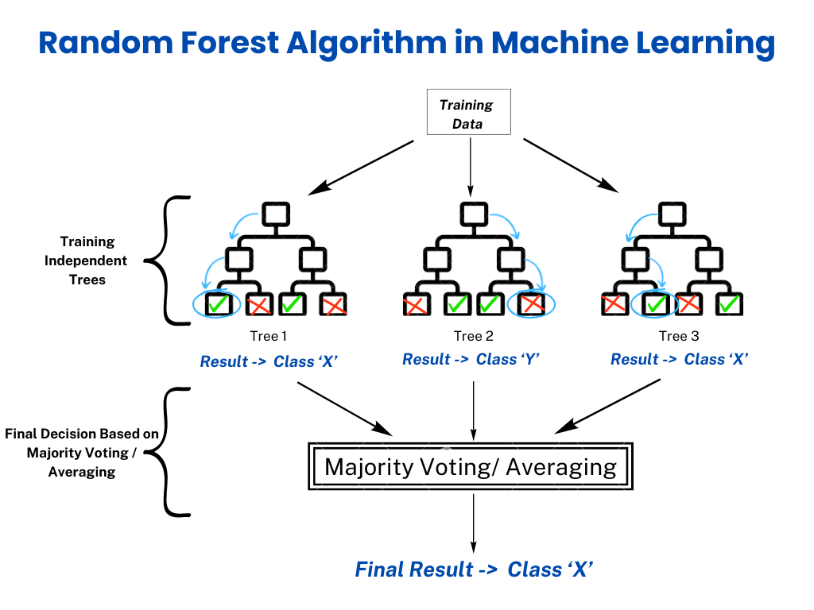

**Fig 3.2 Random Forest Algorithm**

## Mapping Vehicle Profiles to Unique Keys

Once the data was cleaned and organized, the next major task was to map each vehicle profile to a unique identifier, known internally as the XXX key. This key helps service centers identify the exact part or service configuration even when only a partial registration number is available. Building this mapping was the most impactful part of the internship.

Using logic built on Pandas and fuzzy string matching techniques, I created matching conditions based on attributes such as engine type, fuel category, brand, and model. The matching logic had to account for possible variations and partial inputs, as real-world data from service centers often lacks completeness.

Each mapping was given a confidence score depending on the number and weight of matched parameters. A threshold was set to distinguish between high-confidence matches (ready for deployment) and low-confidence ones (needing review). I also designed a fallback mechanism to route uncertain cases for manual review by domain experts.

I collaborated with senior analysts to validate the accuracy of mappings against known vehicle profiles. Feedback from these reviews was used to refine the matching logic and optimize scoring weights. This iterative process helped improve mapping success rates and reduced the dependency on manual validation.

The outcome of this phase was a robust Python-based framework that could take raw input data, clean it, and output a predicted key for further use. This mapping system, once scaled, would directly support part identification at Bosch service centers, improving speed and reducing errors during customer servicing.

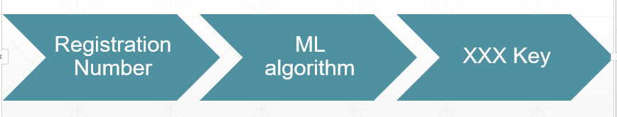

**Fig 3.3 Flowchart**

## Collaboration, Agile Practices, and Documentation

Throughout the internship, I participated in various collaborative and Agile practices that are integral to the team’s workflow. These included daily scrums, biweekly sprint planning, backlog grooming, and retrospective meetings. These ceremonies helped in ensuring continuous progress and resolving blockers quickly.

My work was tracked using **Track and Release**, where I created and updated tickets for each subtask, ensuring traceability and alignment with sprint goals. These tickets included descriptions, timelines, and task dependencies that helped the team plan resources efficiently.

Documentation was another major responsibility. I document data schemas, code snippets, and pipeline workflows. Each preprocessing and mapping script I developed was accompanied by a README file explaining its purpose, inputs, outputs, and usage guidelines.

I also contributed to internal knowledge sharing by preparing brief notes and diagrams that could help future interns or new joiners. These resources covered project overviews, typical errors, and troubleshooting tips based on issues I encountered during testing.

On the softer side, I participated in team catchups, informal feedback sessions, and end-of-sprint celebrations. These activities helped me bond with the team and provided an understanding of how professional and interpersonal dynamics function in a hybrid corporate setting.

**CHAPTER 4**

# REFLECTION NOTES

## Technical Skills Acquired

The internship at Bosch significantly strengthened my technical foundation, especially in the area of data analysis using Python. I worked extensively with the Pandas library to clean, process, and analyze raw vehicle datasets. Through hands-on practice, I became comfortable with data manipulation techniques, handling missing values, and writing efficient code for large datasets.

I also explored machine learning concepts, particularly through the application of the Random Forest algorithm for classification tasks. Although not the central focus of the internship, this exposure to supervised learning gave me a practical understanding of model training, evaluation, and interpretability.

Working with fuzzy string matching and mapping logic helped me learn how real-world problems often require approximate solutions rather than exact matches. Implementing custom matching scores and thresholds was a valuable lesson in designing user-centric, business-driven logic.

The use of Tableau for data visualization was a completely new skill acquired during the internship. I learned to create interactive dashboards that convey insights clearly and support decision-making. In parallel, I used Excel for quick ad hoc analysis, which proved especially helpful during sprint reviews and manual validation.

I also became familiar with various APIs, software tools, and Bosch’s internal tech stack. This included task tracking and documentation, and regular use of Git for version control. These tools are widely used in the industry and provided me with a realistic experience of enterprise-level software development.

Overall, the technical skills I developed were both broad and deep, covering the full lifecycle of data handling—from ingestion and cleaning to analysis, modeling, and visualization—setting a strong base for future projects in data science and analytics.

## Professional and Workplace Exposure

From the first week of orientation, I was exposed to Bosch’s professional working environment, which emphasized structured planning, teamwork, and process discipline. This was my first experience working in a large, globally recognized corporate setting, and it gave me a clear idea of how projects are managed at scale.

Participation in daily scrum meetings helped me stay aligned with team goals, prioritize tasks, and communicate blockers effectively. These short but focused sessions taught me the value of clarity, accountability, and regular updates in maintaining momentum in a project.

I was also part of biweekly sprint reviews, where we presented our progress to team leads and received constructive feedback. These reviews motivated me to ensure that my work was always in a presentable state and aligned with the sprint’s deliverables. The emphasis on documentation and demo-readiness gave me a new perspective on project readiness.

The team followed an Agile methodology, and I learned to adapt to frequent iterations and feedback loops. Unlike academic projects, corporate workflows require flexibility and an ability to pivot quickly based on new data, changing priorities, or stakeholder input. This adaptability was one of the most important soft skills I developed.

I also got to observe and understand how cross-functional teams collaborate—data analysts, product owners, and domain experts worked in tandem to ensure successful project outcomes. I witnessed the importance of inter-departmental communication and saw firsthand how diverse roles contribute to the success of a technical product.

Socially, Bosch provided a warm and inclusive work environment. I participated in team bonding activities, informal outings, and even casual end-of-sprint celebrations. These experiences helped build relationships and made the internship both productive and enjoyable.

## Personal Growth and Career Clarity

The internship allowed me to reflect deeply on my strengths and interests. Initially, I had limited exposure to real-world data projects. But by the end of four months, I felt confident in my ability to take ownership of a data pipeline and contribute meaningfully to a larger product goal.

One of the biggest takeaways was an enhanced sense of problem-solving. Real-world datasets are often messy and inconsistent. Learning to work with such data—debugging issues, writing test scripts, or identifying unexpected anomalies—taught me how to approach ambiguity with patience and logic.

I also developed time management skills, balancing multiple tasks such as development, reporting, testing, and team communication. The practice of using JIRA, updating tickets, and setting personal milestones helped me stay organized and result-oriented.

This internship clarified my career aspirations. I realized that I enjoy working at the intersection of data, business, and technology—an insight that has motivated me to further pursue roles in data analytics, AI-driven products, or product engineering. It also confirmed my interest in full-time opportunities within global tech firms that focus on applied innovation.

Working under pressure and meeting sprint deadlines taught me how to handle stress without compromising the quality of work. I learned to break large problems into smaller components and tackle them with measurable progress checkpoints, a practice I intend to carry forward.

In retrospect, this internship was not just a learning experience, but a transformation journey—from a student with theoretical knowledge to a budding professional with a strong foundation in both technical and workplace competencies.

## Professional and Communication Development

In addition to the technical and analytical skills gained during the internship, a critical outcome was the development of professional behavior and effective communication practices, both of which are essential in real-world software engineering environments. Working on a cross- functional project that involved backend logic, AI integration, and frontend responsiveness required more than just writing code—it demanded clear documentation, structured thinking, time management, and the ability to communicate progress and challenges effectively.

One of the most important aspects of professional development during this internship was **adherence to structured workflows**. Each development task followed a logical progression— from understanding requirements and planning the logic, to coding, testing, and refining. This structured approach mirrored the best practices found in agile development environments and emphasized the importance of breaking down tasks into manageable units. Time management became an integral skill, especially when working on iterative enhancements or debugging complex logic involving asynchronous communication.

Another valuable experience was writing and maintaining **technical documentation**. Each functional component—whether it was an API endpoint, a grading logic function, or the frontend rendering script—was thoroughly documented using inline comments and high-level explanations. The ability to write clear, concise, and informative documentation not only improved the maintainability of the project but also demonstrated the importance of writing code that could be understood and reused by others. This habit of documenting intent and behavior is a hallmark of professional software development and was cultivated throughout the internship.

**Communication skills** were also sharpened through regular written updates, explanatory notes, and the creation of handover-ready documents. These included project summaries, API interaction guidelines, system architecture descriptions, and setup instructions. Crafting these materials required the ability to explain technical details in simple, structured language—an essential skill when working with teammates, non-technical stakeholders, or future developers who may build on the project.

## Real-World Project Exposure

Perhaps the most transformative aspect of the internship was the opportunity to work on a live, functional software project that simulated the conditions and expectations of a real-world development environment. This exposure went far beyond theoretical exercises or classroom assignments, offering a hands-on experience in solving actual problems using modern tools, frameworks, and methodologies. The project—an AI-powered code assistant—integrated intelligent search capabilities, code analysis, and optimization functionalities, all of which reflect the kind of challenges faced in production-grade software systems today.

Unlike academic projects that are often constrained to ideal scenarios with clear boundaries, this internship introduced ambiguity, complexity, and unpredictability—hallmarks of real- world development. For example, the AI outputs were not always consistent, external APIs occasionally returned unexpected results, and frontend rendering had to adapt to various content structures. Tackling these issues required not only technical solutions but also critical thinking, patience, and a willingness to explore alternative approaches.

Importantly, the project had clear, user-focused objectives. The goal wasn’t just to build something functional—it was to create an assistant that could help users understand and improve their code through smart search, AI-driven optimization, and relevant learning resources. This helped shift focus from just “writing code” to solving user problems, an essential perspective for any product engineer or software developer.

In conclusion, this internship provided rich exposure to the kinds of tasks, expectations, and mindsets required in real software development roles. It bridged the gap between theory and practice and highlighted the complexities and rewards of building intelligent systems in today’s technology landscape. This experience has laid a strong foundation for future roles in backend engineering, full-stack development, and AI-integrated application design.

# CONCLUSION

This internship at Bosch was a pivotal experience in my academic and professional journey. It offered me a unique blend of technical challenges, business exposure, and corporate structure, which collectively contributed to my growth as a data analyst and aspiring technologist.

The opportunity to work on a live, confidential project that could have real impact on the company’s service operations made the work exciting and meaningful. Mapping vehicle profiles using partial registration data was a practical problem, and solving it helped me understand how data can directly affect business efficiency and customer satisfaction.

Beyond technical skills, I developed a deeper appreciation for the importance of processes, team coordination, and structured communication. Agile methodologies, regular review mechanisms, and team interactions showed me what it means to build sustainable software solutions.

The supportive work culture at Bosch, combined with a technically sound and structured mentorship system, made the learning curve smoother. Feedback was constructive, expectations were clear, and the work environment encouraged learning by doing.

Looking back, the biggest reward of this internship was the confidence it instilled in me. I now feel more prepared to handle real-world data projects, work within professional teams, and take initiative when needed. I’ve also learned how to communicate technical findings effectively to non-technical stakeholders.

Overall, this experience has solidified my desire to pursue a career in data analytics and AI-driven product development. It has not only equipped me with skills but also given me clarity and direction for my future career path.

# REFERENCES

* + - <https://pandas.pydata.org/docs/>
    - https://scikit-learn.org/stable/
    - https://public.tableau.com/en-us/s/resources
    - <https://support.microsoft.com/en-us/excel>
    - <https://www.bosch.com/>
    - https://www.atlassian.com/agile/scrum
    - https://flask.palletsprojects.com/
    - <https://github.com/seatgeek/fuzzywuzzy>
    - https://www.atlassian.com/software/confluence
    - https://www.atlassian.com/software/jira